Meeting Minutes

Theme: “Today’s Meeting. Tomorrow’s Clarity.”

Meeting Minutes are more than just notes—they are a clear record of what was discussed, what was decided, who is responsible, and what happens next.

“Minutes capture the moment; actions create the movement.”

The picture above uses a creative coffee-cup meeting + notebook concept to make meeting minutes feel modern, friendly, and suitable for a Fitness & Wellness Club, college event, or office meeting.

I can also create a Fitness & Wellness Club–specific meeting-minutes poster with sports, exercise, and Gen-Z style elements

📝 Meeting Minutes – Fitness & Wellness Club

Meeting Overview

The Fitness & Wellness Club meeting was conducted to discuss activities that can improve students’ physical fitness, mental well-being, healthy habits, and teamwork. The members shared ideas and planned upcoming wellness activities
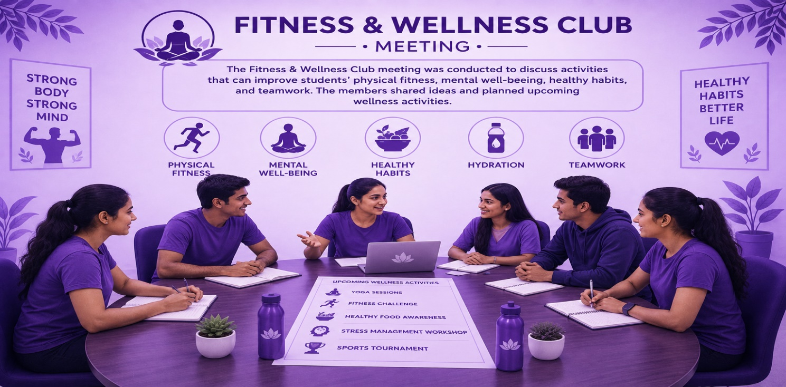

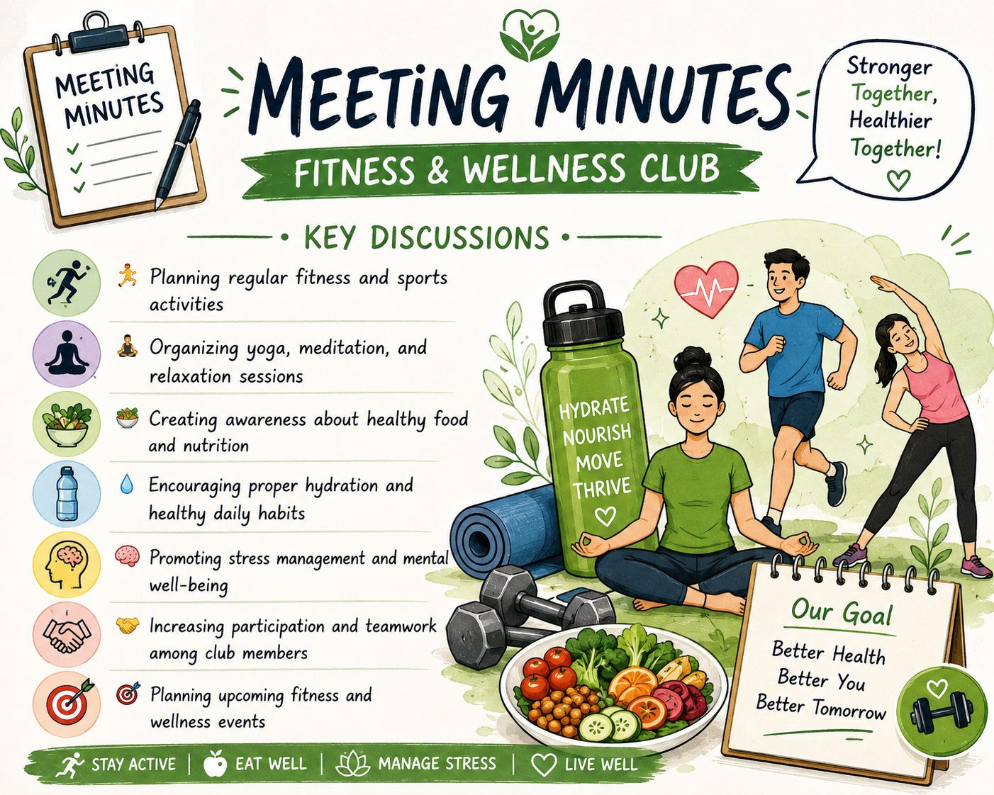.

✅ Decisions Made
- Conduct regular fitness activities.
- Arrange wellness and mindfulness sessions.
- Conduct a nutrition-awareness activity.
- Organize a fun fitness challenge/event.
- Promote club activities among students.

🚀 Action Items
Task | Responsibility
📅 Prepare event schedule | Club Team
🏃 Plan fitness activities | Sports Team
🧘 Organize wellness session | Wellness Team
Promote events | Media Team
📋 Track participation | Club Coordinator
Absolutely. Here is a meeting minutes table for a Fitness & Wellness Club that you can directly add to your report.

🏃 Fitness & Wellness Club – Meeting Minutes
S. No. | Discussion Topic | Key Points Discussed | Action / Decision
1 | 🏃 Fitness Activities | Regular exercise, sports, and fitness sessions | Plan weekly fitness activities
2 | 🧘 Yoga & Meditation | Yoga, meditation, and relaxation practices | Organize regular wellness sessions
3 | 🥗 Healthy Nutrition | Balanced diet and healthy food choices | Conduct nutrition awareness activities
4 | 💧 Hydration & Healthy Habits | Importance of drinking water and maintaining healthy routines | Encourage members to follow healthy habits
5 | 🧠 Mental Well-being | Stress management and relaxation techniques | Include mental wellness activities
6 | 🤝 Member Participation | Teamwork and active participation in club activities | Increase participation through group activities
7 | 🎯 Upcoming Events | Fitness competitions, wellness programs, and awareness events | Prepare schedule for upcoming events

ↈ Meeting Details
Particular | Details
Club Name | Fitness & Wellness Club
Meeting Type | Fitness & Wellness Planning Meeting
Date | 04-09-2008
Time | 4:00 pm
Venue | kundrathur
Chairperson | Tamil selvi
Members Present | Varshini
Next Meeting | 26-09-2026

✨ Closing Note
“Small healthy habits today create a stronger and happier tomorrow.” 💚
Meeting Minutes = a clear record of the discussion, decisions, responsibilities, and next steps from the meeting. 📝🎯

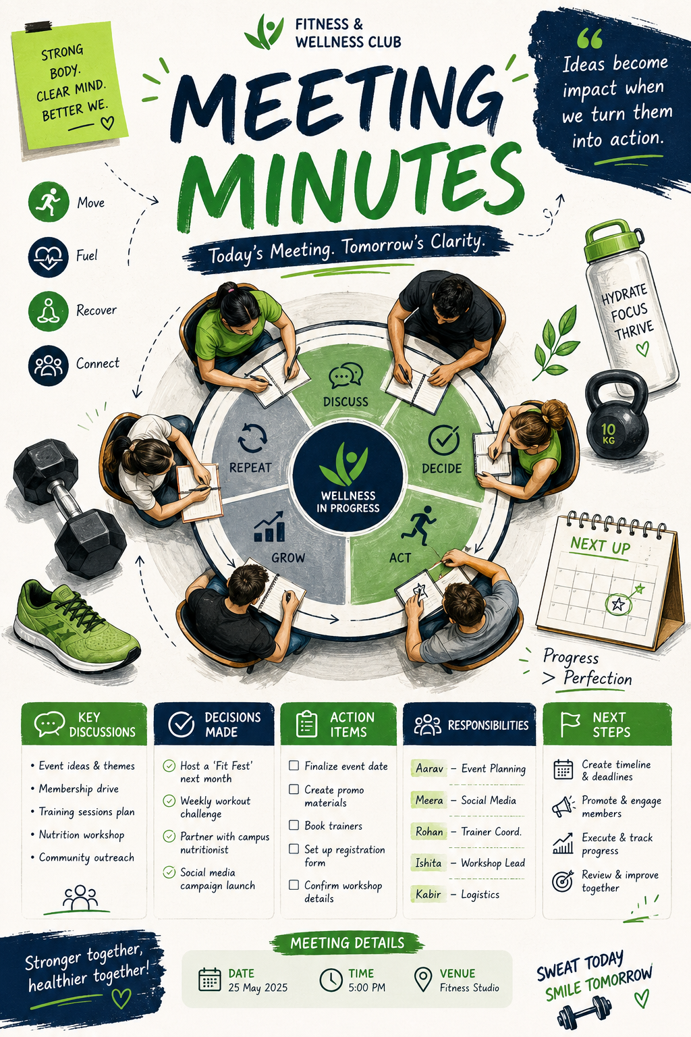
✨ Key sections to include:
- 💡 Ideas Discussed – Important points and suggestions
- ✅ Decisions Made – Final conclusions from the meeting
- 🎯 Action Items – Tasks that need to be completed
- 👥 Responsibilities – Who will handle each task
- 📅 Next Steps – Future plans and deadlines
- 🚀 Progress Check – What has been completed
Unique quote:
“Minutes capture the moment; actions create the movement.”
The picture above uses a creative coffee-cup meeting + notebook concept to make meeting minutes feel modern, friendly, and suitable for a Fitness & Wellness Club, college event, or office meeting.
I can also create a Fitness & Wellness Club–specific meeting-minutes poster with sports, exercise, and Gen-Z style elements

